Part Number: PT546-52100

Kit Contents

|  |  |  |
| --- | --- | --- |
| Item # | Quantity Reqd. | Description |
| 1 | 1 | Navigation H-U |
| 2 | 1 | Accessory Box |

Accessory Box Contents

|  |  |  |
| --- | --- | --- |
| Item # | Quantity Reqd. | Description |
| 1 | 1 | iPod Cable |
| 2 | 1 | Cord Assembly |
| 3 | 1 | Spacer |
| 4 | 1 | Spacer |
| 5 | 2 | Knockout Cover |
| 6 | 1 | GPS Antenna Assembly |
| 7 | 1 | AUX Harness |
| 8 | 1 | Microphone Assembly |
| 9 | 1 | Accessory Bag 1 |
| 10 | 1 | Accessory Bag 2 |
| 11 | 1 | Scion Bag |

Accessory Bag 1

|  |  |  |
| --- | --- | --- |
| Item # | Quantity Reqd. | Description |
| 1 | 1 | Wire Cord Clip |
| 2 | 4 | Protective Sheet |
| 3 | 4 | Cushion Tape (Large) |
| 4 | 4 | Cushion Tape (Small) |
| 5 | 13 | Lock Tie |

Accessory Bag 2

|  |  |  |
| --- | --- | --- |
| Item # | Quantity Reqd. | Description |
| 1 | 8 | Screw |

Scion Bag

|  |  |  |
| --- | --- | --- |
| Item # | Quantity Reqd. | Description |
| 1 | 1 | Quick Start Guide |

Additional Items Required For Installation

|  |  |  |
| --- | --- | --- |
| Item # | Quantity Reqd. | Description |
|  |  |  |

Conflicts

|  |
| --- |
| None |

**Vehicle Service Parts** (may be required for reassembly)

|  |  |  |
| --- | --- | --- |
| Item # | Quantity Reqd. | Description |
|  |  |  |

Recommended Tools

|  |  |
| --- | --- |
| Personal & Vehicle Protection | Notes |
| Blankets, Masking Tape, Vinyl Tape |  |
|  |  |
|  |  |
| Special Tools | Notes |
| None |  |
|  |  |
| Installation Tools | Notes |
| Panel Clip Removal Tool | e.g. Toyota SST P/N:-  00002-06002-01 |
| Wrench | Open End, 10mm |
| Socket | 10mm, 8mm |
| Ratchet |  |
| Extension |  |
| Screwdriver | Phillips |
| Torque Wrench | 48 in・lbf |
| Pliers |  |
| Scissors |  |
| Nipper |  |
| Needle Nose Pliers |  |
|  |  |
| Special Chemicals | Notes |
| None |  |
|  |  |

General Applicability

|  |
| --- |
|  |

Recommended Sequence of Application

|  |  |
| --- | --- |
| Item # | Accessory |
| 1 | Navigation System |

\*Mandatory

Legend

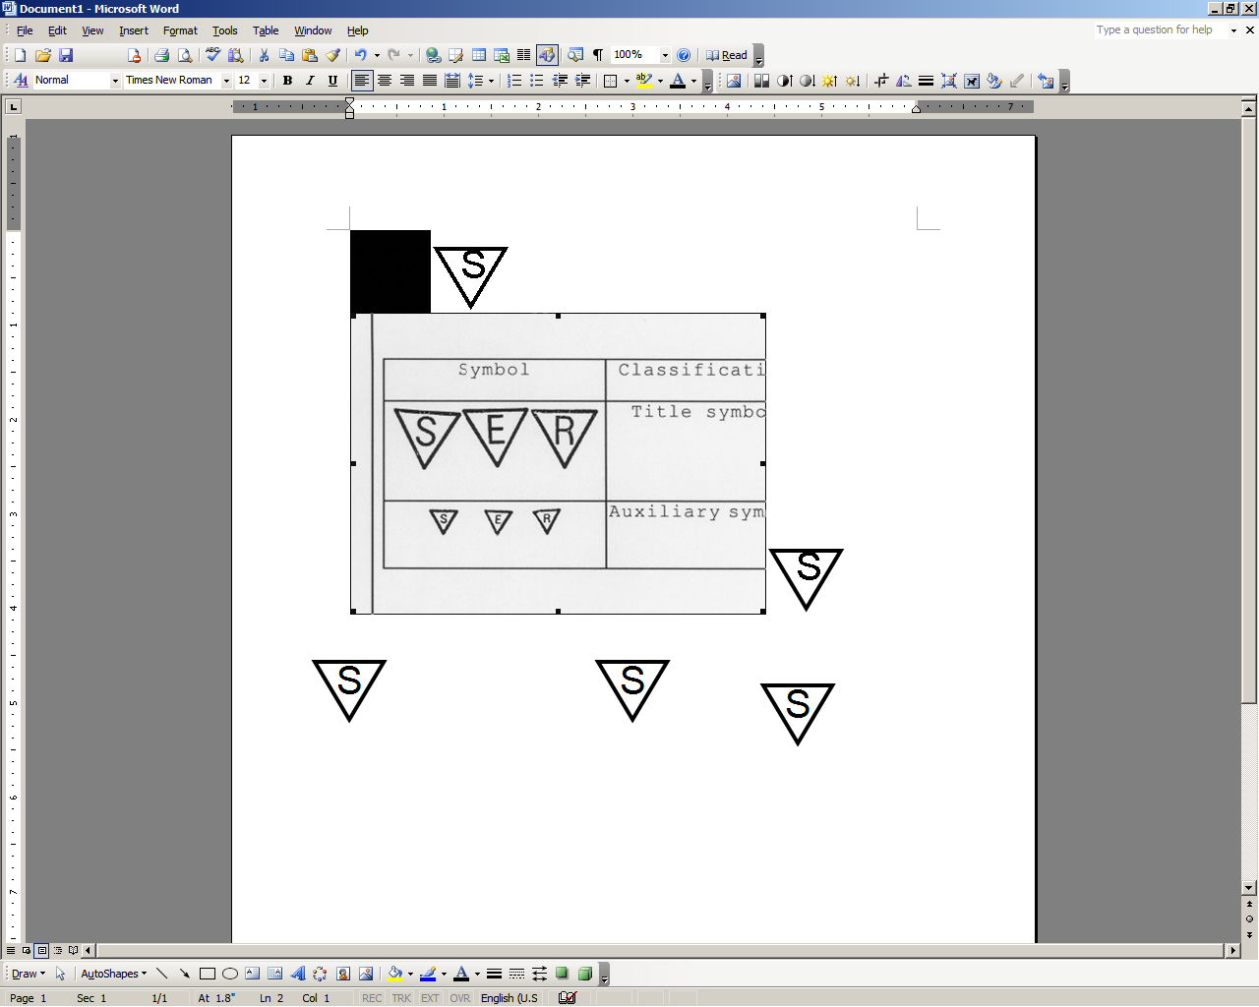

**STOP:** Damage to the vehicle may occur. Do not proceed until process has been complied with.

**OPERATOR SAFETY:** Use caution to avoid risk of injury.

**CAUTION:** A process that must be carefully observed in order to reduce the risk of damage to the accessory/vehicle and to ensure a quality installation.

**TOOLS & EQUIPMENT:** Used in Figures calls out the specific tools and equipment recommended for this process.

**REVISION MARK:** This mark highlights a change in installation with respect to previous issue.  
  
**SAFETY TORQUE:** This mark indicates that torque is related to safety.



Parts Description of Navigation System (PT546-52100)

2

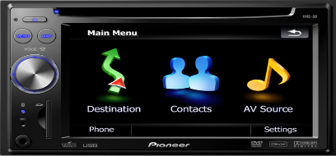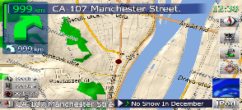

1

|  |  |  |  |
| --- | --- | --- | --- |
| Item # | Part Name | Part No. | Qty |
| 1 | Navigation H-U | AVIC-F7010BT/XS/UC | 1 |
| 2 | Accessory Box | - | 1 |

Parts Description of Accessory Box

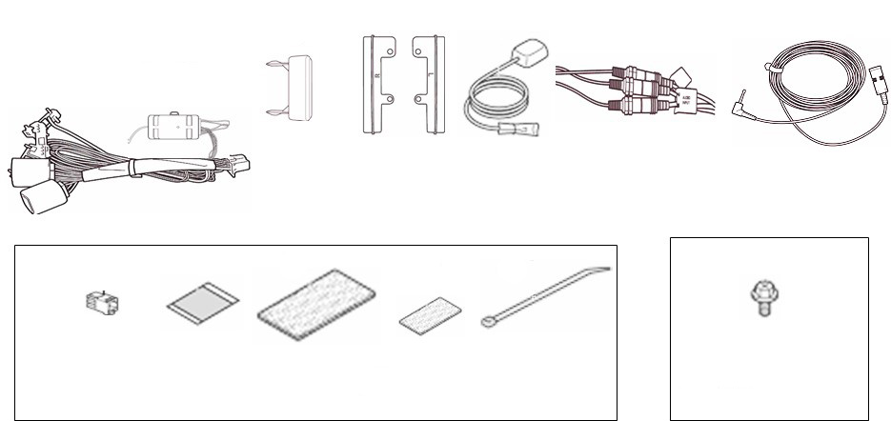

G

Scion Bag

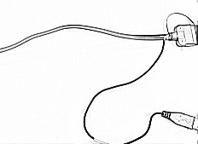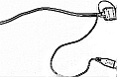

1

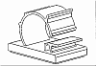

2

3

4

5

6

7

8

A

B

C

D

E

F

Accessory Bag 1

Accessory Bag 2

|  |  |  |  |
| --- | --- | --- | --- |
| Item # | | Part Name | Qty |
| 1 | | iPod Cable | 1 |
| 2 | | Cord Assembly | 1 |
| 3 | | Knockout Cover | 2 |
| 4 | | Spacer (Left) | 1 |
| 5 | | Spacer (Right) | 1 |
| 6 | | GPS Antenna Assembly | 1 |
| 7 | | AUX Harness | 1 |
| 8 | | Microphone Assembly | 1 |
| Acc Bag 1 | A | Wire Cord Clip | 1 |
| B | Protective Sheet (15 x 85) | 4 |
| C | Cushion Tape (Large 135 x 80) | 4 |
| D | Cushion Tape (Small 100 x 50) | 4 |
| E | Lock Tie | 13 |
| Acc Bag 2 | F | Screw (M5 x 8) | 8 |
| Scion Bag | G | Quick Start Guide | 1 |

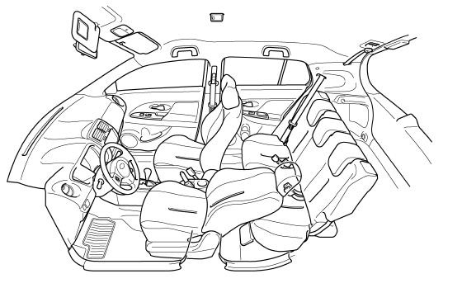

Microphone, headliner, by mirror

iPod / USB, glove box

REV / PKB connections

GPS Antenna, under dash panel

Care must be taken when installing this accessory to ensure damage does not occur to the vehicle. The installation of this accessory should follow approved guidelines to ensure a quality installation.

These guidelines can be found in the "Accessory Installation Practices" document.

This document covers such items as:-

* Vehicle Protection (use of covers and blankets, cleaning chemicals, etc.).
* Safety (eye protection, rechecking torque procedure, etc.).
* Vehicle Disassembly/Reassembly (panel removal, part storage, etc.).
* Electrical Component Disassembly/Reassembly (battery disconnection, connector removal, etc.).

Please see your Scion dealer for a copy of this document.

Protect the Vehicle.

* 1. Remove the negative battery cable (Fig. 1-1).

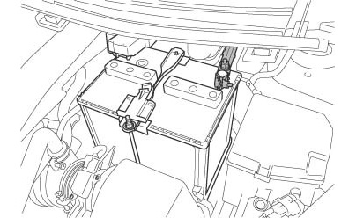

Ratchet, 10mm socket



Negative battery cable

Battery

Fig. 1-1

* + 1. stop_2Protect the fender before starting.
    2. safety_2Do not touch the positive terminal with any tools when removing the cable.

Disassemble the Vehicle.

stop_2**NOTE:** Place all removed parts on a protected surface.

stop_2**NOTE:** When disconnecting wiring connectors do NOT pull on the wiring, pull on the connector only.

stop_2**NOTE:** Engage the parking brake while working.

* 1. Remove the instrument panel cluster finish center panel.
     1. Disengage the 2 claws and 7 clips and remove the instrument panel cluster finish center panel (Fig. 2-1).

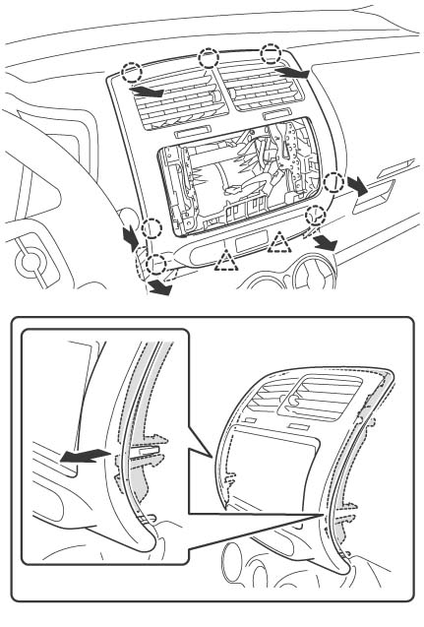

Fig. 2-1

Instrument panel cluster finish center panel

B

C

B

A

Clip (×7)

Claw (×2)

A

Clip B

Retainer

##### caution_2NOTE: Disengage the clips in the order A to C as shown in the illustration.

* + 1. Disconnect the connector and put a mark on it (Fig. 2-1).

stop_2**NOTE:** Remove the instrument panel cluster finish center panel while preventing the retainer from separating from the vehicle (Inset, Fig. 2-1).

* 1. Remove the 4 screws from the radio brackets (L and R) to remove the brackets from the vehicle (Fig. 2-2).

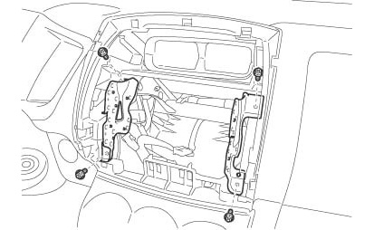

Fig. 2-2

Radio bracket (L)

Screw (×4)

Phillips screwdriver, 8mm socket



Radio bracket (R)

* 1. Remove the meter cluster panel.
     1. Apply masking tape to the upper side of the steering column upper cover (Fig. 2-3).

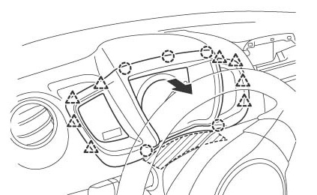

Meter cluster panel

Claw (×8)

Masking tape

Clip (×5)

Masking

A

B

B

C

Fig. 2-3

C

Steering column upper cover

* + 1. Tilt the steering column down and push the wiper lever down.
    2. Disengage the 8 claws and 5 clips in the order A to C as shown in the illustration, and remove the meter cluster panel (Fig. 2-3).
  1. Remove the combination meter assembly.
     1. Remove the 2 screws, disengage the 2 clips and remove the combination meter assembly (Fig. 2-4).

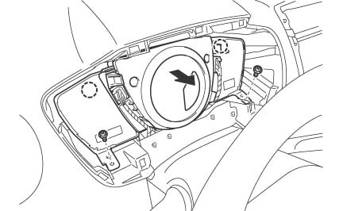

Phillips screwdriver, 8mm socket

Fig. 2-4

Clip (×2)

Screw (×2)

Combination meter assembly

* + 1. Disconnect the connectors (Fig. 2-4).
  1. Disengage the 2 claws and remove the instrument panel box (Fig. 2-5).

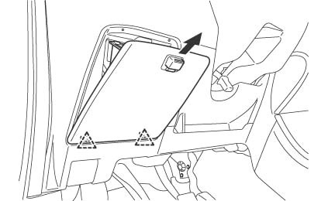

Fig. 2-5

Instrument panel box

Claw (×2)

* 1. Remove the front pillar garnish (L).
     1. Disengage the 2 clips from the vehicle (Fig. 2-6).

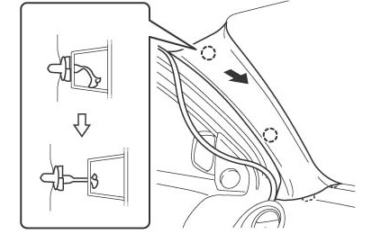

Fig. 2-6

Front pillar garnish (L)

Clip B

Clip A

Clip B

* + 1. Pull the front pillar garnish so that the tip of clip B locks in the front pillar garnish hole (Fig. 2-6).
    2. Use needle-nose pliers with the jaws wrapped in tape to prevent damage to rotate clip B 90° (Fig. 2-7).

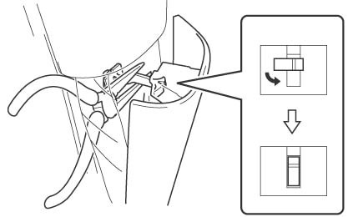

Fig. 2-7



Needle-nose pliers with masking tape

Clip B

Front pillar garnish (L)

* + 1. Pull the front pillar garnish (L) in the direction of the arrow (Fig. 2-8).

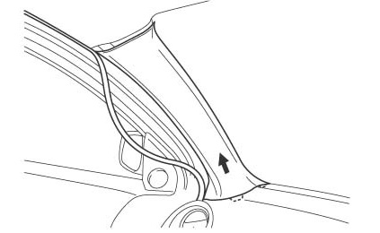

Fig. 2-8

Front pillar garnish (L)

**stop_2NOTE**: If clip B is damaged (i.e. scarred) or if it is removed from the body, install a new clip B. Confirm the latest clip part number on the electronic parts catalog.

* 1. Remove the front pillar garnish (L) and the glove compartment door.
     1. Disconnect the damper from the glove compartment door.
     2. Squeeze both ends of the box together to fully extend the box, and then remove the stoppers (Fig. 2-9).

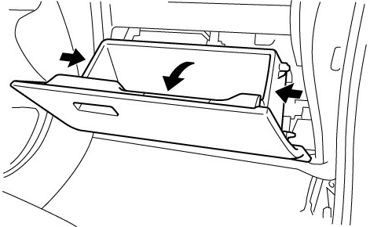

Stopper (× 2)

Damper

Claw (×2)

Fig. 2-9

* + 1. Disconnect the glove compartment door damper from the vehicle side.
    2. Disengage the claws, and then remove the glove compartment door.
  1. Remove the center console.

**Automatic Transmission:**

* + 1. Apply the parking brake and move the shifter to N. Remove the cover and push the release button to unlock the shifter.
    2. Disengage the 2 clips and 6 claws to remove the shift knob trim panel (Fig. 2-10).

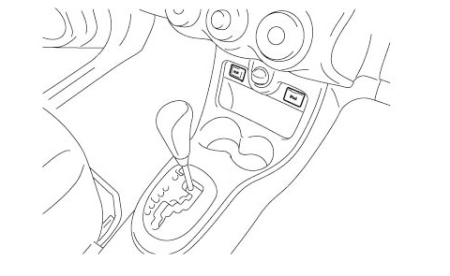

Fig. 2-10

Clip (× 2)

**Manual Transmission:**

* + 1. Unscrew the shifter knob.

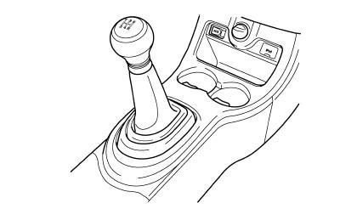

Clip (× 2)

Fig. 2-11

* + 1. Disengage the 2 clips and 6 claws to remove the shift knob trim panel (Fig. 2-11).
    2. Remove the 4 screws located in front of the shifter (Fig. 2-12).

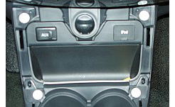

Phillips screwdriver, 10mm socket

Fig. 2-12

* + 1. Remove the bolt located in the center console cup holder.
    2. Reach under the panel to disengage the 9 claws to remove the trim piece located between the parking brake and the shifter (Fig. 2-13).

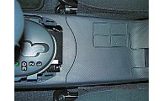

Fig. 2-13

* + 1. Remove the bolt located in the center console cup holder. Lift the center console and move it backwards. It is not necessary to remove the piece from the vehicle (Fig. 2-14).

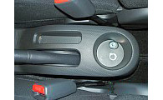

10mm socket

Fig. 2-14

* + 1. Remove the cover panel around the iPod & AUX connections (Fig. 2-10 or Fig. 2-11).
    2. Disengage the 4 clips to remove the HVAC control panel. It is not necessary to disconnect the controls. Use appropriate protection methods and rest the panel to the side (Fig. 2-15).

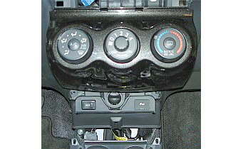

Fig. 2-15

Install the Navigation System.

* 1. As shown in the illustration, cut 2 foam tape sheets (135mm x 85mm) into 12 pieces (Fig. 3-1).

Fig. 3-1

Scissors

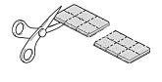

× 12

Foam tape (× 2)

**NOTE:**

・Used to fix the GPS antenna cord - 1  
・Used to fix the REV signal wire   
・Used to fix the PKB signal wire 8  
・Used to fix the Microphone wire  
・Wrap OE iPod & AUX wires - 2

* 1. Install the iPod & AUX knock out covers.
     1. Remove both the iPod and AUX sockets by releasing the clips on the L & R side of the sockets and push them out (Fig. 3-2).

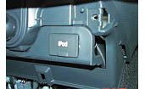

Fig. 3-2

* + 1. Reach down from the HVAC area to release the inner clips of each of the sockets.
    2. Release the outer clips from the panel openings on the outside of the connections.
    3. Push each socket housing out towards the passenger compartment. Release the L & R clips when removing the sockets.
    4. Disconnect the wire harness from each socket, wrap both with a small cut foam tape, and push the wrapped harness back into opening.
    5. Replace these 2 receptacles with knock out covers.
    6. Reinstall the HVAC trim panel at this time to prevent possible damage.
  1. Apply 4 protection sheets to the sharp edges (Fig. 3-3).

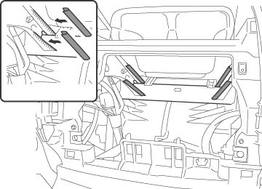

Fig. 3-3

Protection sheet (15 x 85mm)

Edge

Protection sheet (15×85mm) ×4

Reinforcement

caution_2**NOTE:** Before attaching the protection sheet, wipe off any dirt, water or oil from the attachment surface.

* 1. Install the GPS antenna.
     1. Remove the GPS antenna & ground plate form the bag; discard the included fasteners.
     2. Separate the release paper from the ground plate and attach it on top of the center air duct. The center duct slopes down to a flat spot that can be reached from the combination meter area (Fig. 3-4).

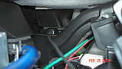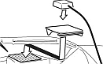

Fig. 3-4

Foam tape

Air duct



GPS antenna, under dash panel

* + 1. Place the GPS antenna on the ground plate and fix it with foam tape.
  1. Temporarily route the GPS antenna cord to the navigation system installation location (Fig. 3-5).

Fig. 3-5

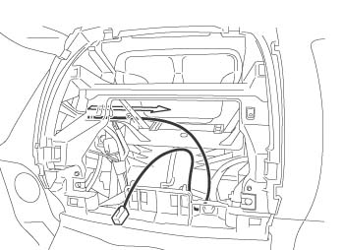

GPS antenna cord

* 1. Remove the radio harness and AM/FM antenna cable.
     1. Remove the tape which is securing the radio harness (Fig. 3-6).

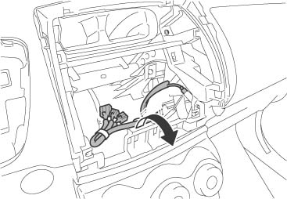

Radio harness

Taping

Antenna cable

Fig. 3-6

* + 1. Pull the antenna cable out from the instrument panel hub.
  1. Route the wire harness.
     1. Connect cord assembly to the vehicle audio harnesses.

* + 1. Route the PKB signal wire (Red / White) and REV signal wire (Green) from the wire harness, along the vehicle wire harness, to the vicinity of combination meter (Fig. 3-7).

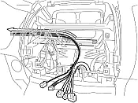

Fig. 3-7

PKB signal wire (Red / White)

Audio harness

Antenna cord

REV signal wire (Green)

Vehicle wire harness

Wire harness

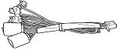

Cord assembly

* 1. Temporarily route the PKB signal wire and REV signal wire.
     1. Temporarily route the REV signal wire (Green) and the PKB signal wire (Red / White) from the wire harness along the vehicle wire harness (Fig. 3-8).

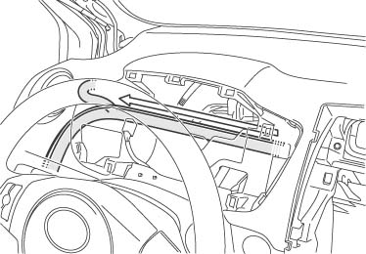

Fig. 3-8

PKB signal wire (Red / White)

REV signal wire (Green)

Vehicle wire harness

* + 1. Temporarily route the REV signal wire (Green) and the PKB signal wire (Red / White) from the wire harness along the vehicle wire harness to the instrument panel J/B (Fig. 3-9).

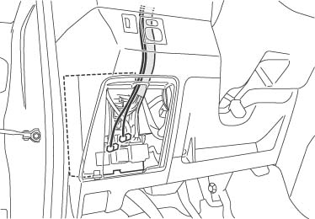

Fig. 3-9

PKB signal wire (Red / White)

REV signal wire (Green)

Vehicle wire harness

Instrument panel J/B

* + 1. Disconnect the white 16P connector and the white 30P connector from the instrument panel J/B (Fig. 3-10).

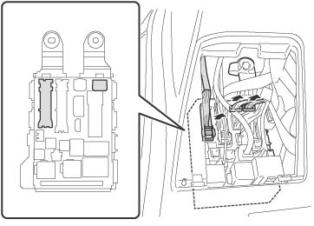

Fig. 3-10

Front view

Instrument panel J/B

30P (White)

Instrument panel J/B

16P (White)

14P (White)

caution_2**NOTE**: If it is hard to disconnect the white 16P connector, disconnect the white 14P connector first.

* 1. Connect the PKB signal wire.
     1. Connect the yellow wire (7th pin from the top left) from the white 16P connector to the PKB signal wire (Red / White) from the wire harness (Fig. 3-11).

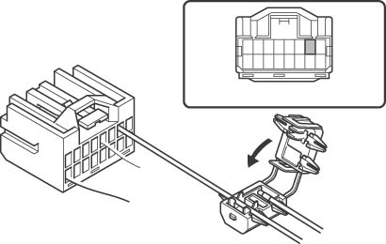

Fig. 3-11

16P (White)

Vehicle wire harness (Yellow)

PKB signal wire (Red / White)

Splicing connector

16P on the wire harness side

* + 1. Use pliers to engage the splicing connector (Fig. 3-12).

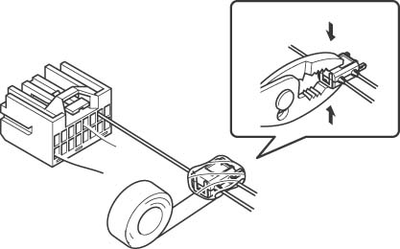

Fig. 3-12

16P (White)

Splicing connector

Pliers

Vinyl tape



Pliers

* + 1. Wrap vinyl tape around the splicing connector (Fig. 3-12).
    2. Reconnect the white 16P connector.
    3. Connect the REV signal wire.
    4. Connect the red wire (1st pin bottom row from the left) from the white 30P connector to the REV signal wire (Green) from the wire harness (Fig. 3-13).

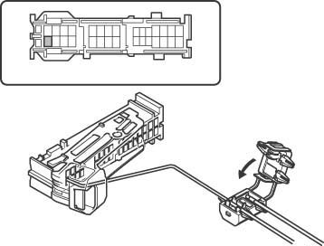

Fig. 3-13

30P (White)

Vehicle wire harness (Red)

REV signal wire (Green)

Splicing connector

30P on the wire harness side

* + 1. Use pliers to engage the splicing connector (Fig. 3-14).

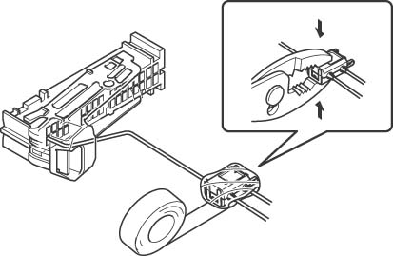

Fig. 3-14

30P (White)



Pliers

Vinyl tape

Pliers

Splicing connector

* + 1. Wrap vinyl tape around the splicing connector (Fig. 3-14).
    2. Reconnect the white 30P connector.
  1. Install the microphone clip.
     1. Remove the microphone and the clip from the pink bag.
     2. Install the microphone into the clip and route the wire through the channel in the clip (Fig. 3-15).



Fig. 3-15

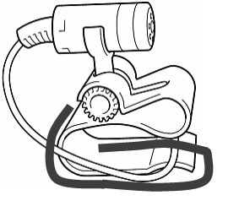

Channel

Foam tape

Scissors

* + 1. Place a cushion tape (small) on the clip. Line up the cushion tape close to the rotating cylinder piece and push along the clip to the open end (Fig. 3-15).
    2. Use scissors to trim the cushion along the sides and end of the microphone clip.
    3. caution_2Use extra caution not to cut the microphone wire while trimming the foam tape.
  1. Install the microphone clip to the head liner.
     1. Gently pull the head liner back and install the microphone clip (Fig. 3-16).

Fig. 3-16

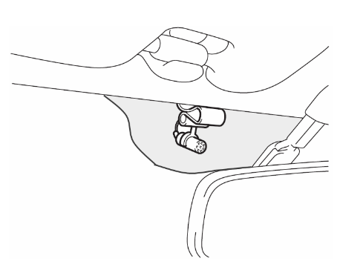

30 mm

* + 1. The left side of the microphone clip should be placed 30 mm from the corner of the shaded area behind the mirror (Fig. 3-16).
  1. Route the microphone wire.
     1. Tuck the microphone wire along the head liner towards the driver side A-pillar.
     2. Apply 4 lock ties to the cable along the A-pillar (Fig. 3-17). Trim the lock ties after the wire is secured.

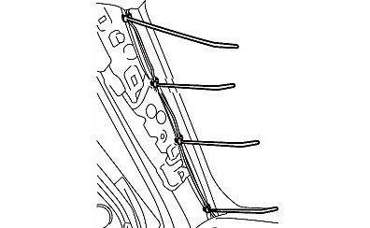

Lock tie (×4)

Fig. 3-17

* + 1. Route the microphone wire along the vehicle wire harness to the radio location.
  1. Fix the REV signal wire and PKB signal wire.
     1. Take the REV signal wire (Green) and PKB signal wire (Red / White) from the wire harness and fix them to the vehicle wire harness with foam tape (Fig. 3-18).

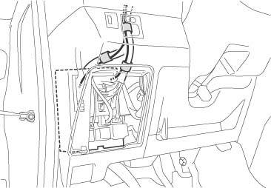

Fig. 3-18

REV signal wire (Green)

Vehicle wire harness

Foam tape (×3)

PKB signal wire (Red / White)

* + 1. Bundle excess GPS antenna, PKB, REV, & microphone wires together & fix to vehicle harness with a lock tie.
    2. Secure the antenna cord, REV signal wire (Green) and PKB signal wire (Red / White) to the vehicle harness with 5 foam tapes (Fig. 3-19).

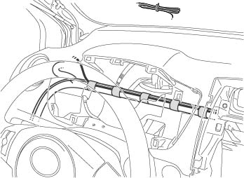

Fig. 3-19

Vehicle wire harness

Foam tape (×5)

PKB signal wire (Red / White)

REV signal wire (Green)

Mic cord (Black)

Lock tie

* 1. Install the bracket with spacer.
     1. Place the black spacer on the appropriate bracket. A tab on the bracket fits into a slot on the spacer.
     2. Install the brackets with 8 M5 x 8 screws (Fig. 3-20).

Tab

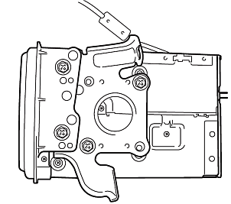

Ratchet, 10mm socket

Fig. 3-20

M5 bolt

* 1. Prep the iPod & USB cables.
     1. Loosely knot the iPod cable approximately 280 mm from the iPod customer end (Fig. 3-21). The long side of a standard letter page can be used for reference.

Fig. 3-21

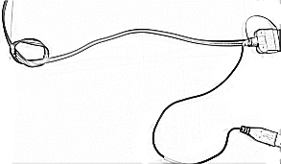

280 mm

* + 1. Knot the USB cable from the head unit using the same method as the iPod connection.
  1. Fix the USB & iPod cables together.
     1. Use the illustration to fix the iPod and navigation USB cables together with 3 lock ties (Fig. 3-22).

Lock tie (× 3)

60

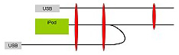

130

80

Fig. 3-22

* + 1. Connect the 3 RCA connections on the iPod cable to the 3 matching connections on the white AUX harness. These will be marked as “Audio Input” & “Video Input” (Fig. 3-23).

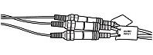

Fig. 3-23

* + 1. Secure each connection with small foam tape.
  1. Bundle the cords.
     1. Gather the navigation connections shown, and estimate the correct length of each cord. Consider serviceability standard when doing so (Fig. 3-24).

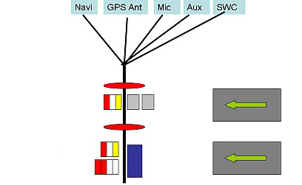

Fig. 3-24

Lock tie (×2)

SWC

iPod

RCA

Cushion (×2)

Connectors

* + 1. Use 2 lock ties to contain the bundle where indicated.
    2. Wrap 2 large cushions around the bundle where indicated.

**caution_2Caution:** The clock connector should not be included in this bundle.

* 1. Route the iPod cable.
     1. Place the navigation unit on the seat and route the iPod & USB cables (Fig. 3-25).



iPod / USB

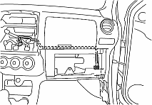

Fig. 3-25

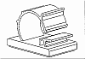

Wire knots

Upper edge of glove box

Clip

* + 1. Loop the white clip through the knots in the iPod and USB cables.
    2. Peel the release paper from the clip and fix it to the back side of the trim located above the glove box. Use the right edge of the upper storage box as a guide.

caution_2**Caution:** Adhesive on the clip will not be effective if the clip is removed and applied again.

* 1. Install the navigation system.
     1. Connect the white AUX harness, navigation harness, blue GPS antenna connection, microphone, AM/FM antenna, and mini jack from the SWC control box to the “wired remote”.
     2. Place the navigation unit in the instrument panel while tucking the wire bundle down behind the HVAC controls (Fig. 3-26).

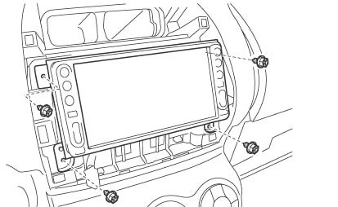

Fig. 3-26



Phillips screwdriver

Screw (×4)

Navigation system

* 1. Fix the iPod wire
     1. Carefully pull the slack out of the instrument panel area to behind the glove box.
     2. Fix the cables along the vehicle harness with 2 lock ties (Fig. 3-27).

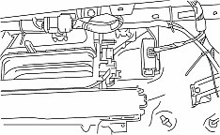

Lock tie (×3)

Bundle

Fig. 3-27

* + 1. Bundle the excess from both cords and fix to the vehicle harness with 1 additional lock tie.

Perform an In-process Function Check - Check the REV/PKB Signal Wire Connection.

* 1. Reconnect the vehicle’s negative battery cable (Fig. 4-1).

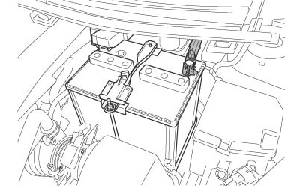

Torque wrench, 10mm socket



Negative battery cable

Battery

Fig. 4-1

* + 1. Position the negative terminal back to the factory position.
    2. Tighten the nut to 48 in-lbs (5.4 N-m).

**Torque: 48 in-lbs (5.4 N-m)**

* + 1. safety_2Do not touch the positive terminal with any tools when replacing the cable.
    2. Temporarily install the dome fuse.
    3. Turn the key to ACC.
  1. Connect the parking brake.
     1. From the main menu touch settings, confirm that “Navi Settings” & “System Settings” are greyed out.
     2. Pull the parking brake and confirm that these options are now available for use.

**caution_2NOTE:** The parking brake will need to be engaged to confirm many of the functions, so it should be left on if possible.

* 1. Check the AV settings.
     1. From the settings menu select “AV settings”.
     2. Press “AV1” once so iPod is shown.
     3. Select “VR Catalog Mode”. Turn this function off by selecting “Off”.
     4. Press the return arrow in the upper right corner 2 times to return to the settings menu.
  2. Check the navigation settings.
     1. Select “Navi Settings” from the settings menu.
     2. Press OK for the disclaimer if it appears.
     3. Select “GPS & Time Settings”.
     4. Use the bar graph along the bottom of the screen to verify the GPS antenna connection.

**caution_2Note:** The vehicle will need a clear view of the sky to confirm a GPS signal.

* 1. Check the microphone.
     1. Press the “Map” button on the navigation unit.
     2. At the map screen, press the main volume knob in and a voice menu will appear.
     3. Speak “Change source to AM” to confirm the microphone is working.
  2. Check the steering wheel controls. Use the volume and track buttons on the steering wheel and confirm proper operation.

##### Complete the Installation.

* 1. Complete the reassembly of the vehicle.
     1. **caution_2**Reconnect any disconnected connectors.
     2. **caution_2**Verify the panels fit together properly with no uneven gaps between them.
  2. Clean up and remove any trash.
  3. Place the owner’s manuals left in their protective bags, iPod cable, DVD jewel case, and Scion guide in the glove box.
  4. Remove the dome fuse.

Vehicle Function Checks

Hazard Switch

Air Conditioner

Front Passenger Seat Belt Monitor

Door Key Lock Monitor

Refer to the Car Owner’s Manual, and return the Power Windows to their initial positions.

Refer to your Car Owner’s Manual, and return the Back Door Lock to its initial position.

TRAC, TPMS, Combination Meter, Parking Brake and Reverse

Vehicle Appearance Check

After accessory installation and removal of protective cover(s), perform a visual inspection.

Functioning Hazard Switch

Functioning Air Conditioner

Functioning Front Passenger Seat Belt Monitor

Functioning Door Key Lock Monitor

Auto-open and Auto-close operation of each of the Power Windows is possible with the driver’s seat master switch.

Door Lock and Unlock functions operate correctly.

Ensure LED operation

Ensure no damage (including scuffs and scratches) was caused during the installation process.

(For PPO installations, refer to TMS Accessory Quality Shipping Standard.)